Name: Jesus Guerrero

# System Design:

The design of my system was to create a car dealership. The dealership has a home page where the user can leave their information for the dealership to contact them. They can browse through used and new cars listed by the dealership, and if they have a used car they would like to sell, they can input the information to list it.

# ER Model:

New Cars

Car Dealership

Orders

Customers

Used Cars

Has

Has

Made By

Has

Lists

# Tables:

**Customer Information**

|  |  |  |  |
| --- | --- | --- | --- |
| First Name | Last Name | Email (Primary Key) | Subject |
| Tom | Washington | tomWashington@email.com | No subject |
| Jeff | Bice | jbice@cars.com | Want to buy a car |
| Randy | Reynolds | Randynolds@gmail.com | Null |

**New Cars**

|  |  |  |  |  |
| --- | --- | --- | --- | --- |
| Make (Primary Key) | Type | Year | Price | Image |
| Dodge Grand Caravan | SUV | 2010 | $9,995 | Suvwhite.jpg |
| Hyundai | Sedan | 2019 | $20,240 | 2019Hyundai.jpg |
| Ford F150 | Truck | 2019 | $72,780 | Red2019Ford.jpg |
| Lexus GS F | Sedan | 2016 | $57,900 | 2016Lexus.jpg |

**Used Cars**

|  |  |  |  |  |  |  |  |
| --- | --- | --- | --- | --- | --- | --- | --- |
| Make (Primary Key) | Type | Year | Price | Miles | Owner Email | Other Info | Image |
| Ford Taurus | Sedan | 2003 | $900 | 999,999 mi | contact@info.com | More info | Fordtaurus.jpg |
| Hyundai Accent SE | Sedan | 2017 | $9,000 | 38,000 mi | owner@email.com | The 2017… | 2017hyundai.jpg |
| Honda Civic LX | Coupe | 2002 | $4,295 | 98,410 mi | [realEmail@gmail.com](mailto:realEmail@gmail.com) | No other info | greenhonda.jpg |

# Queries and Code

The home page has a form that a customer can fill out. It requests a first name, last name, email, and optional subject. It uses customers.php to insert the data from the form into the contactInfo database.

Screenshot of Index.php:



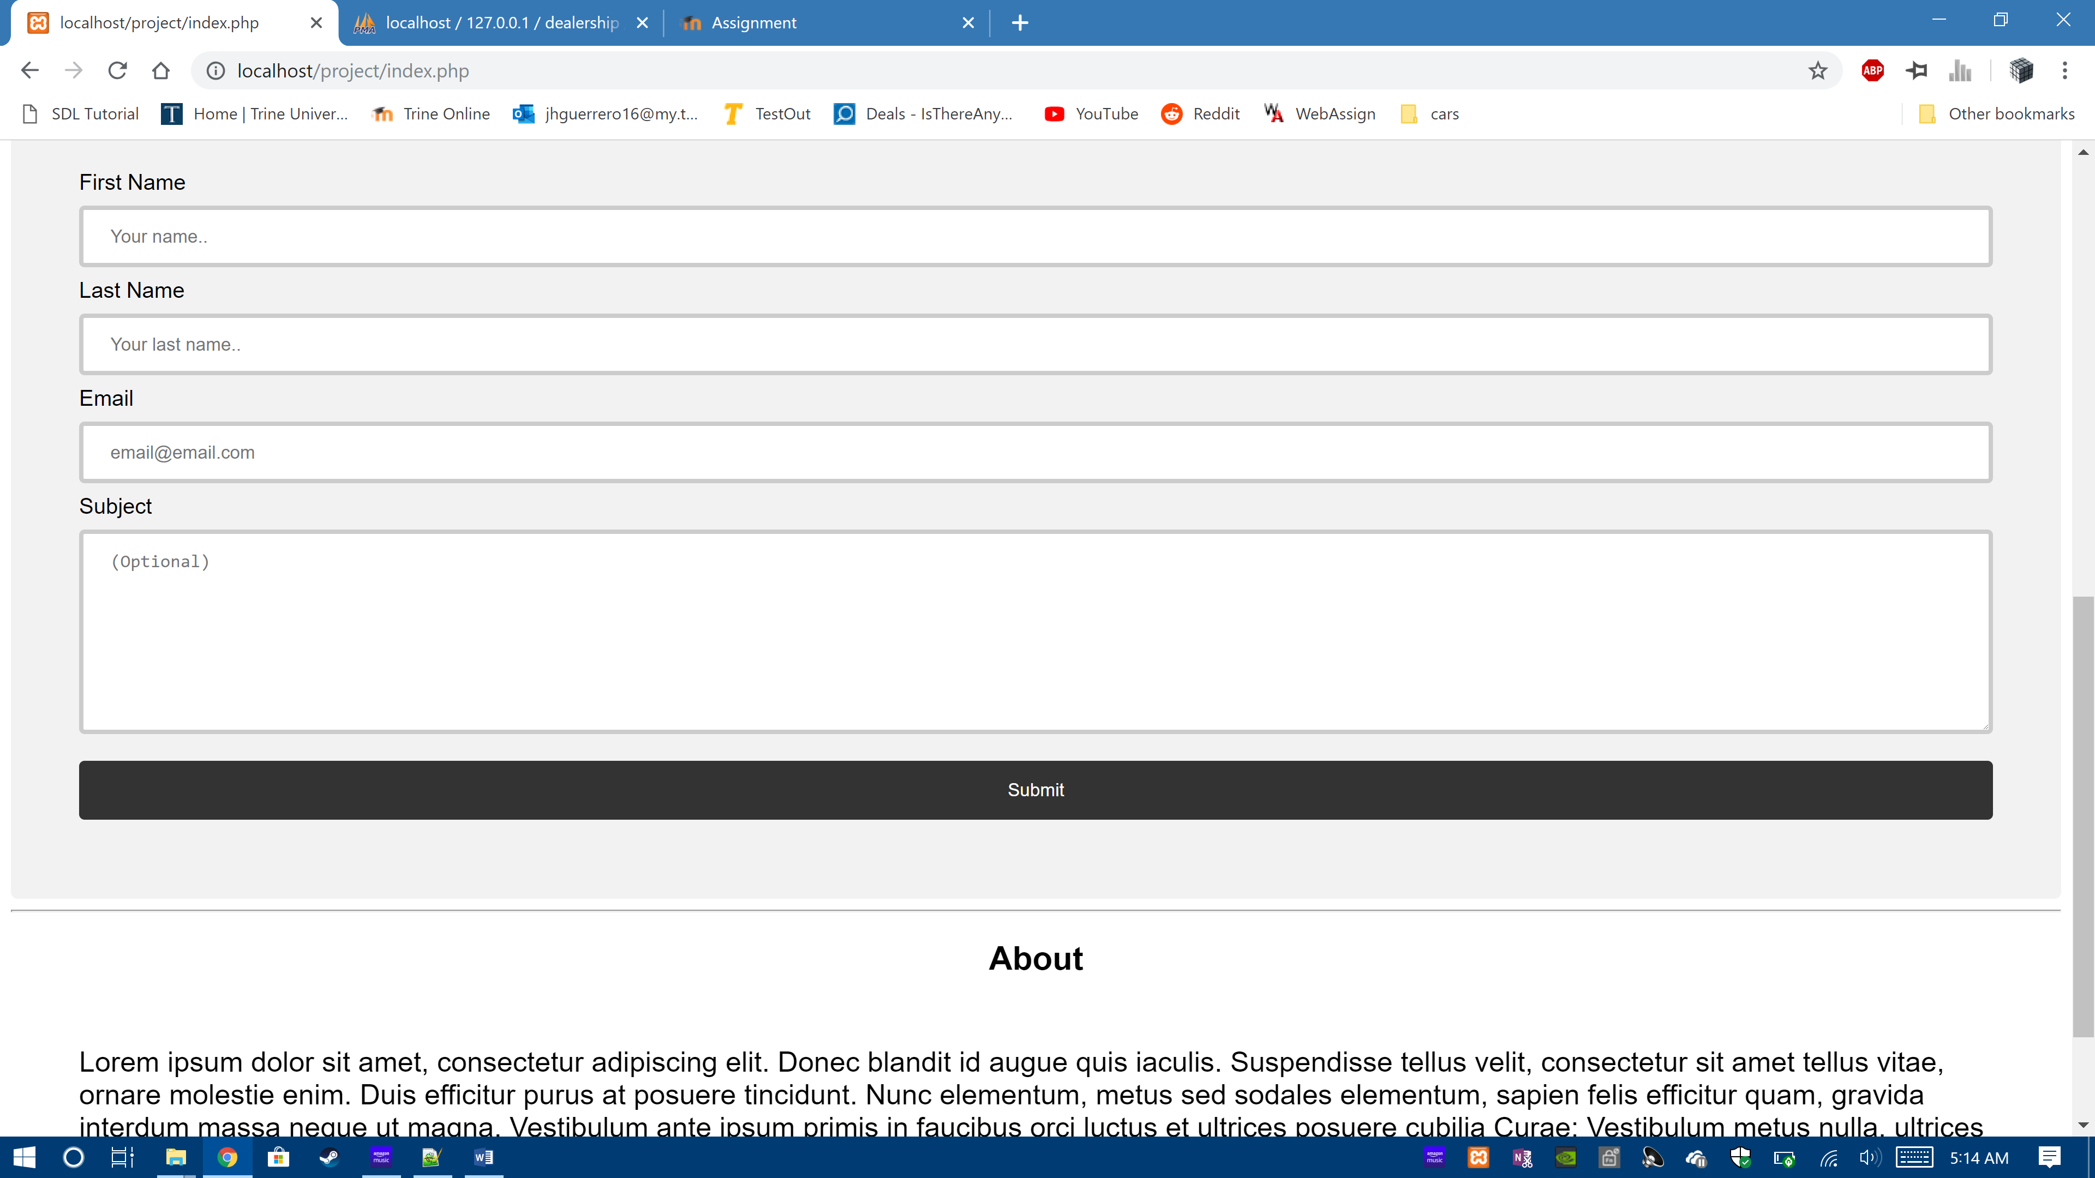

Code for customers.php. It contains a insert into query to insert the data into the database.

<?php

include ('config.php');

$fname = $_POST['firstname'];

$lname = $_POST['lastname'];

$email = $_POST['email'];

$subject = $_POST['subject'];

//Validation for the form

if (empty($_POST["firstname"])) {

echo "Error: First name is required";

header("refresh:3 url = index.php");

return false;

} else {

$name = test_input($_POST["firstname"]);

if (!preg_match("/^[a-zA-Z ]*$/",$name)) {

echo "Error: Only letters and white space allowed";

header("refresh:3 url = index.php");

return false;

}

}

if (empty($_POST["lastname"])) {

echo "Error: Last name is required";

header("refresh:3 url = index.php");

return false;

} else {

$name = test_input($_POST["lastname"]);

if (!preg_match("/^[a-zA-Z ]*$/",$name)) {

echo "Error: Only letters and white space allowed";

header("refresh:3 url = index.php");

return false;

}

}

if (empty($_POST["email"])) {

echo "Error: Email is required";

header("refresh:3 url = index.php");

return false;

} else {

$email = test_input($_POST["email"]);

if (!filter_var($email, FILTER_VALIDATE_EMAIL)) {

echo "Error: Invalid email format";

header("refresh:3 url = index.php");

return false;

}

}

$sql = "INSERT INTO contactInfo(fname,lname,email,subject) VALUES('$fname','$lname','$email','$subject')";

if (mysqli_query($conn, $sql)) {

echo "Request sent successfully";

} else {

echo "Error: " . $sql . "<br>" . mysqli_error($conn);

}

header("refresh:4 url = index.php");

function test_input($data) {

$data = trim($data);

$data = stripslashes($data);

$data = htmlspecialchars($data);

return $data;

}

mysqli_close($conn);

?>

The next page is the services page. It lists services that customers can make an appointment for. It redirects them to a contact form which uses the above customers.php.

Screenshots of services.php:

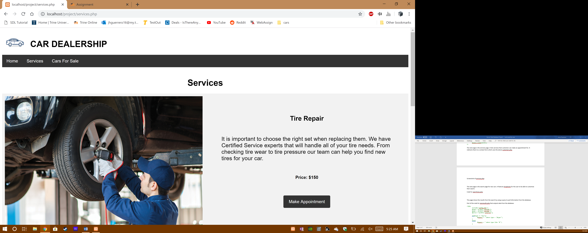

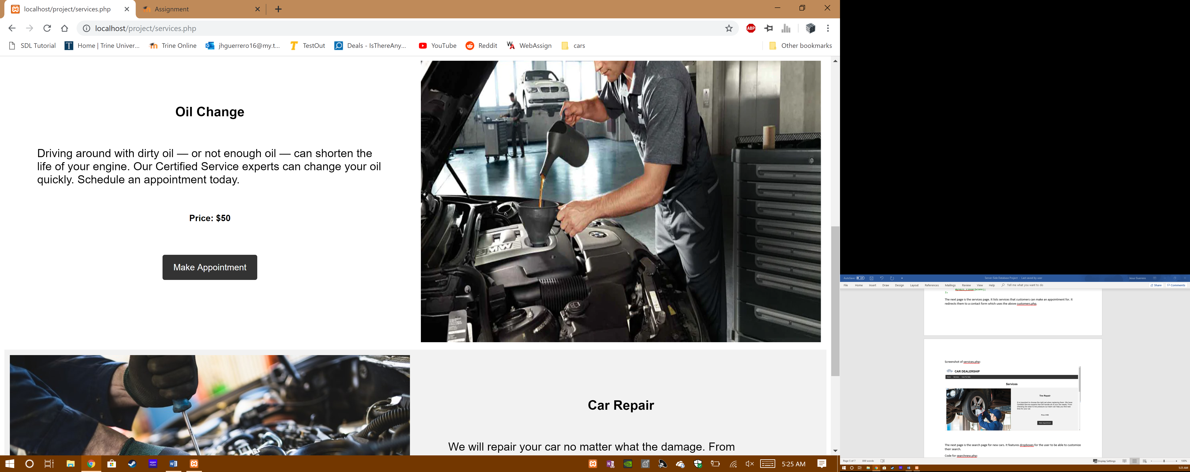

This page is the contact form that appears when the user presses a button on the services page. It uses customers.php to insert the data into the contactInfo database and functions the same way as the one on the home page.

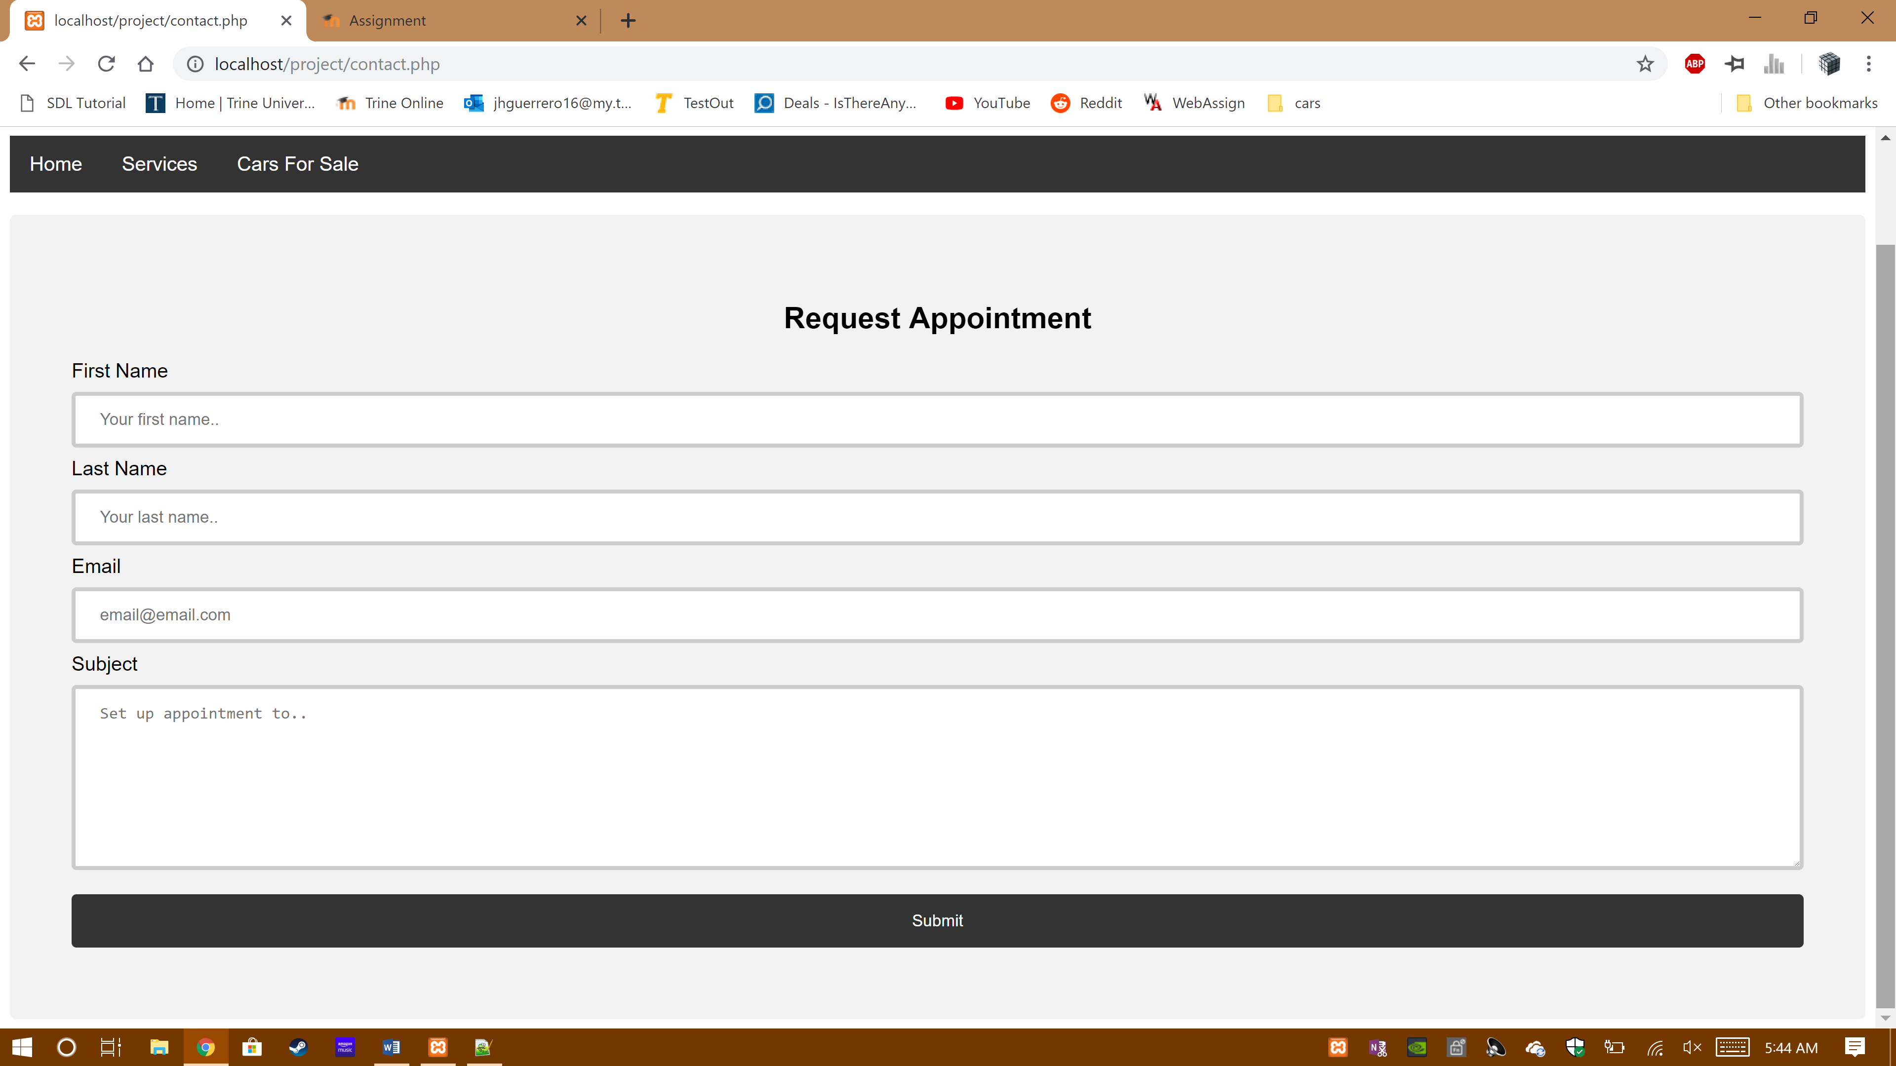

The next page is the search page for new cars. It features dropboxes for the user to be able to customize their search.

Screenshots for searchnew.php:

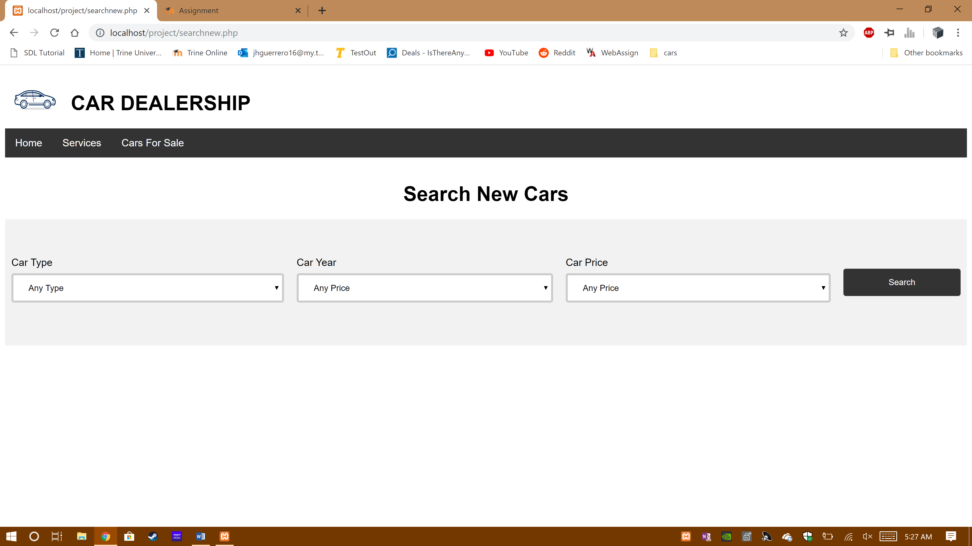

This page shows the results from the search by using a query to pull information from the database.

Screenshots for newresults.php:

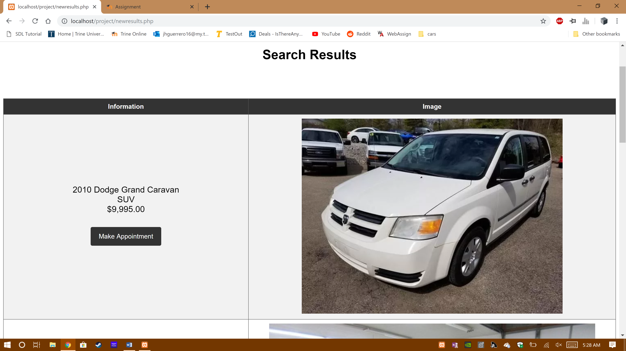

Part of the code for newresults.php. It outputs data from the newcars database into a table that the user can read by using a select from query.

<?php

include('config.php');

$type = $_POST['cartype'];

$year = $_POST['caryear'];

$price = $_POST['carprice'];

if($type != "any"){

$tquery = " where type = '$type'";

}

else{

$tquery = " where type like '%'";

}

if($year != "any"){

$yquery = " and year < '$year'";

}

else{

$yquery = "";

}

if($price == "any"){

$pquery = "";

}

else if($price == "60000"){

$pquery = " and price > '$price'";

}

else{

$pquery = " and price < '$price'";

}

$sql = "select * from newcars" . $tquery . $yquery . $pquery;

$result = mysqli_query($conn,$sql);

echo "<p>";

if(mysqli_num_rows($result) > 0)

{

echo "<table border = 1 bgcolor = 'white''>

<tr>

<th width='40%'>Information</th>

<th width='60%'>Image</th>

</tr>";

while($row = mysqli_fetch_assoc($result))

{

echo "<tr>";

echo "<td><p id='intro'>" .$row["year"]. " " .$row["make"]. "</br>" .$row["type"]. "</br>$" .number_format($row["price"],2).

"</br></br><a href='contact.php'><button class='button button1'>Make Appointment</button></a></p></td>";

echo "<td><img src='upload/" .$row["image"]. "'></td>";

echo "</tr>";

}

}else

{

echo "<tr>No results found</tr>";

}

echo "</table>";

echo "</p>";

?>

</br>

<p align="center"><a href="searchnew.php"><button class="button button1">Search Again</button></a></p>

</body>

</html>

The next page is the search for used cars. It functions similar to the new car search but has more options.

Screenshot for searchused.php:

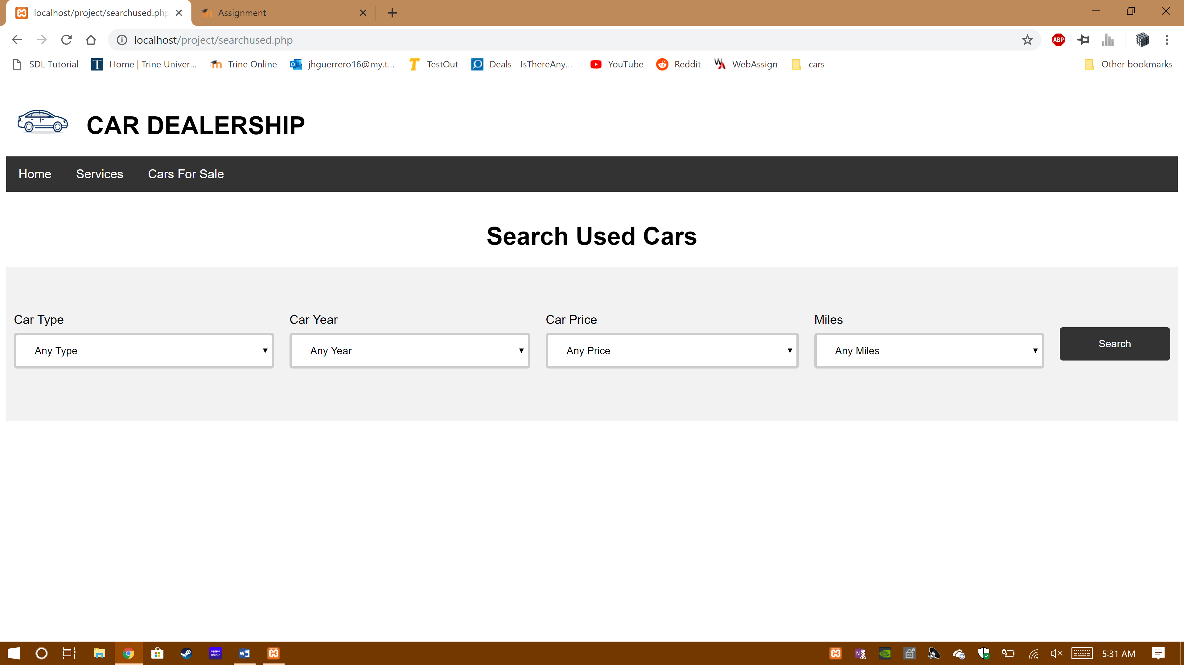

This page shows the results from the search by using a query to pull information from the database, similar to the new search.

Screenshots for usedresults.php:

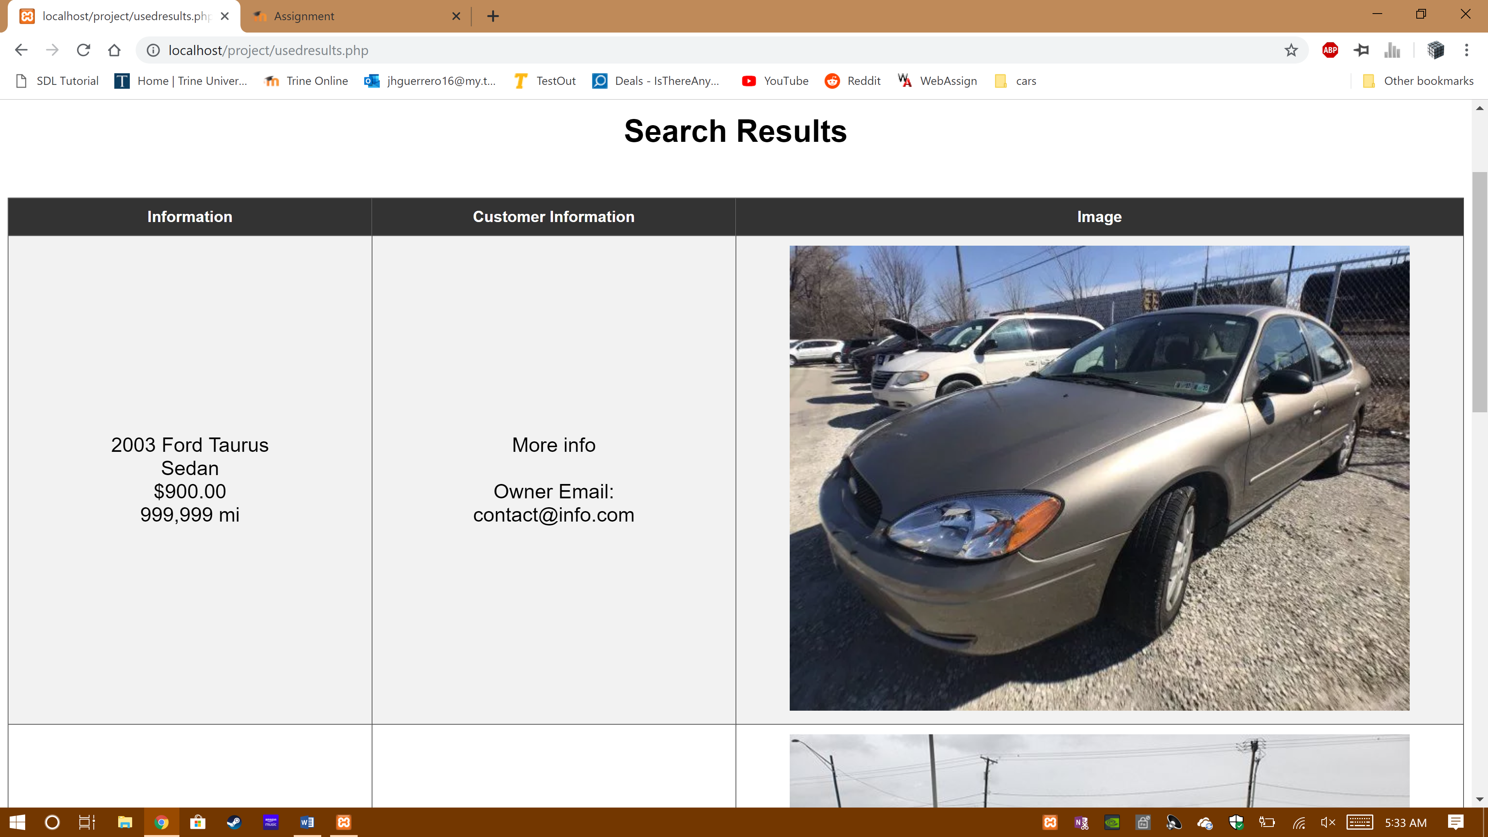

Part of the code for usedresults.php that outputs data from the usedcars database. It functions the same way as newresults.php, using a select from query to output data.

<?php

include('config.php');

$type = $_POST['cartype'];

$year = $_POST['caryear'];

$price = $_POST['carprice'];

$miles = $_POST['miles'];

if($type != "any"){

$tquery = " where type = '$type'";

}

else{

$tquery = " where type like '%'";

}

if($year != "any"){

$yquery = " and year < '$year'";

}

else{

$yquery = "";

}

if($price == "any"){

$pquery = "";

}

else if($price == "60000"){

$pquery = " and price > '$price'";

}

else{

$pquery = " and price < '$price'";

}

if($miles == "any"){

$mquery = "";

}

else if($miles == "100000"){

$mquery = " and miles > '$miles'";

}

else{

$mquery = " and miles < '$miles'";

}

$sql = "select * from usedcars" . $tquery . $yquery . $pquery . $mquery;

$result = mysqli_query($conn,$sql);

echo "<p>";

if(mysqli_num_rows($result) > 0)

{

echo "<table border = 1 bgcolor = 'white'>

<tr>

<th width='25%'>Information</th>

<th width='25%'>Customer Information</th>

<th width='50%'>Image</th>

</tr>";

while($row = mysqli_fetch_assoc($result))

{

echo "<tr>";

echo "<td><p id='intro'>" .$row["year"]. " " .$row["make"]. "</br>" .$row["type"].

"</br>$" .number_format($row["price"],2). "</br>" .number_format($row["miles"]). " mi</p></td>";

echo "<td><p id='intro'>" .$row["info"]. "</br></br>Owner Email: " .$row["email"]. "</p></td>";

echo "<td><img src='upload/" .$row["image"]. "'></td>";

echo "</tr>";

}

}else

{

echo "<tr>No results found</tr>";

}

echo "</table>";

echo "</p>";

?>

The final page is a form that allows the user to enter data and upload a picture to list their car.

Screenshot of sell.php:

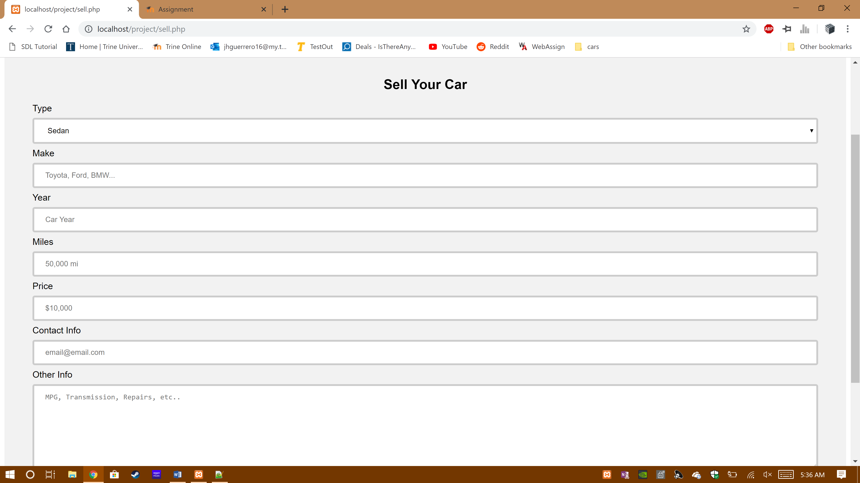

The following is code for listcar.php, a page called by sell.php so it can input the data from the previous form into the usedcars database. It uses a insert into query to insert the data into the database.

<?php

include('config.php');

$type = $_POST['type'];

$make = $_POST['make'];

$year = $_POST['year'];

$miles = $_POST['miles'];

$price = $_POST['price'];

$email = $_POST['email'];

$info = $_POST['info'];

if (empty($_POST["make"])) {

echo "Error: Please enter the make of the car.";

header("refresh:3 url = sell.php");

return false;

} else {

$name = test_input($_POST["make"]);

if (!preg_match("/^[a-zA-Z ]*$/",$name)) {

echo "Error: Only letters and white space allowed";

header("refresh:3 url = sell.php");

return false;

}

}

if (empty($_POST["year"])) {

echo "Error: Please enter the year of the car.";

header("refresh:3 url = sell.php");

return false;

} else {

if (!is_numeric($year)) {

echo "Error: Only numerical values allowed.";

header("refresh:3 url = sell.php");

return false;

}

}

if (empty($_POST["miles"])) {

echo "Error: Please enter the miles of the car.";

header("refresh:3 url = sell.php");

return false;

} else {

if (!is_numeric($miles)) {

echo "Error: Only numerical values allowed.";

header("refresh:3 url = sell.php");

return false;

}

}

if (empty($_POST["price"])) {

echo "Error: Please enter the price of the car.";

header("refresh:3 url = sell.php");

return false;

} else {

if (!is_numeric($price)) {

echo "Error: Only numerical values allowed.";

header("refresh:3 url = sell.php");

return false;

}

}

if (empty($_POST["email"])) {

echo "Error: Email is required";

header("refresh:3 url = index.php");

return false;

} else {

$email = test_input($_POST["email"]);

if (!filter_var($email, FILTER_VALIDATE_EMAIL)) {

echo "Error: Invalid email format";

header("refresh:3 url = index.php");

return false;

}

}

$year = filter_var($year, FILTER_SANITIZE_NUMBER_INT);

$price = filter_var($price, FILTER_SANITIZE_NUMBER_INT);

$miles = filter_var($miles, FILTER_SANITIZE_NUMBER_INT);

$target_dir = "upload/";

$target_file = $target_dir . basename($_FILES["pic"]["name"]);

$image = basename($_FILES["pic"]["name"]);

$uploadOk = 1;

$imageFileType = strtolower(pathinfo($target_file,PATHINFO_EXTENSION));

// Check if image file is a actual image or fake image

if(isset($_POST["submit"])) {

$check = getimagesize($_FILES["pic"]["tmp_name"]);

if($check !== false) {

echo "File is an image - " . $check["mime"] . ".";

$uploadOk = 1;

} else {

echo "File is not an image.";

$uploadOk = 0;

}

}

// Check file size

if ($_FILES["pic"]["size"] > 500000) {

echo "Sorry, your file is too large.";

$uploadOk = 0;

}

// Allow certain file formats

if($imageFileType != "jpg" && $imageFileType != "png" && $imageFileType != "jpeg"

&& $imageFileType != "gif" ) {

echo "Sorry, only JPG, JPEG, PNG & GIF files are allowed.";

$uploadOk = 0;

}

// Check if $uploadOk is set to 0 by an error

if ($uploadOk == 0) {

echo "Sorry, your file was not uploaded.";

// if everything is ok, try to upload file

} else {

if (move_uploaded_file($_FILES["pic"]["tmp_name"], $target_file)) {

$sql = "INSERT INTO usedcars(make,type,year,price,miles,email,info,image) VALUES('$make','$type','$year','$price','$miles','$email','$info','$image')";

} else {

echo "Sorry, there was an error uploading your file.";

}

}

if (mysqli_query($conn, $sql)) {

echo "Car listed successfully";

} else {

echo "Error: " . $sql . "<br>" . mysqli_error($conn);

}

header("refresh:4 url = sell.php");

function test_input($data) {

$data = trim($data);

$data = stripslashes($data);

$data = htmlspecialchars($data);

return $data;

}

mysqli_close($conn);

?>